Login to AWS Management Console and search for S3 service.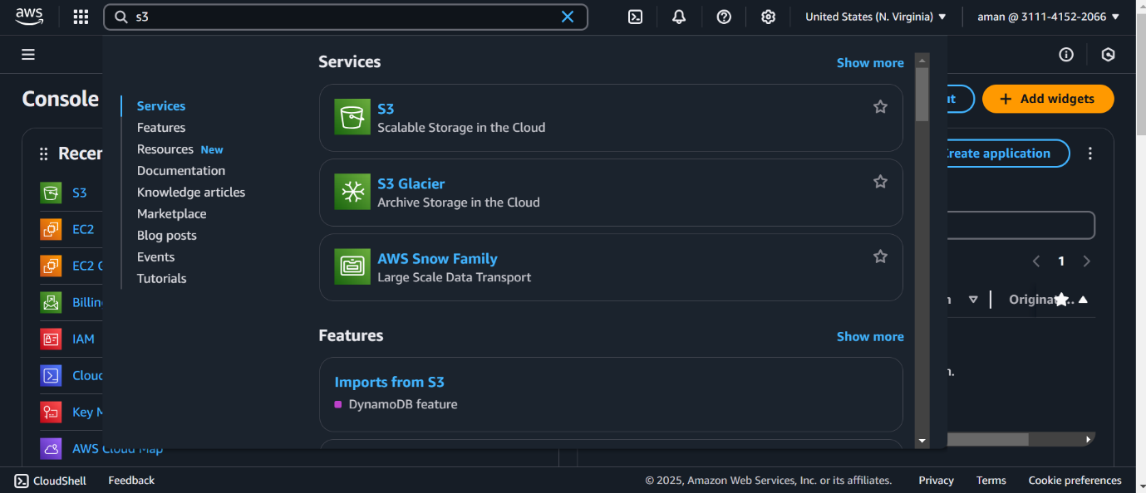

Click on “create bucket” button.

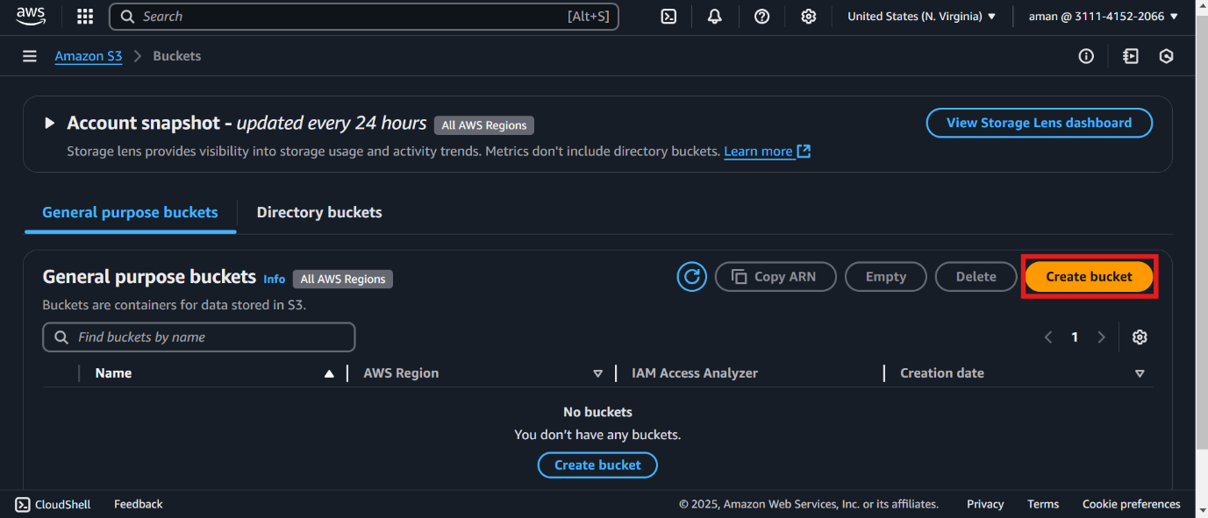

Provide a name for your S3 bucket.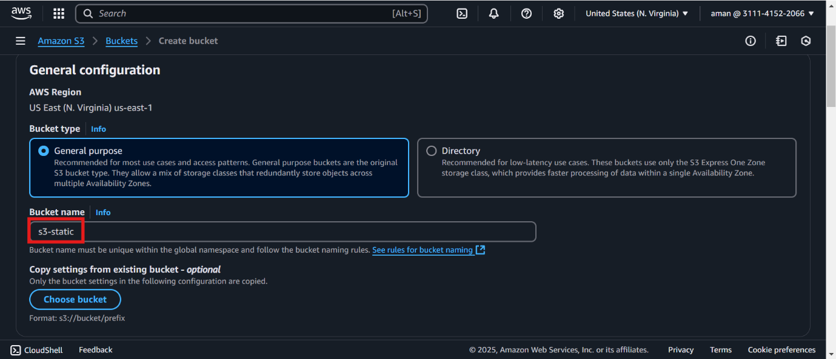

Uncheck the “Block all public access flag” and check on the public access acknowledgment.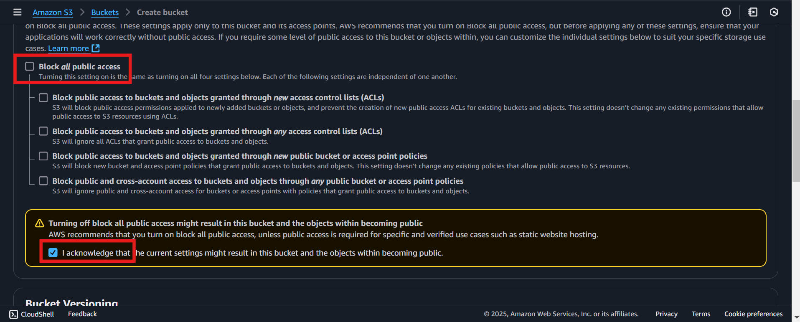

Then click on “create bucket” again and you will see your new S3 bucket created.